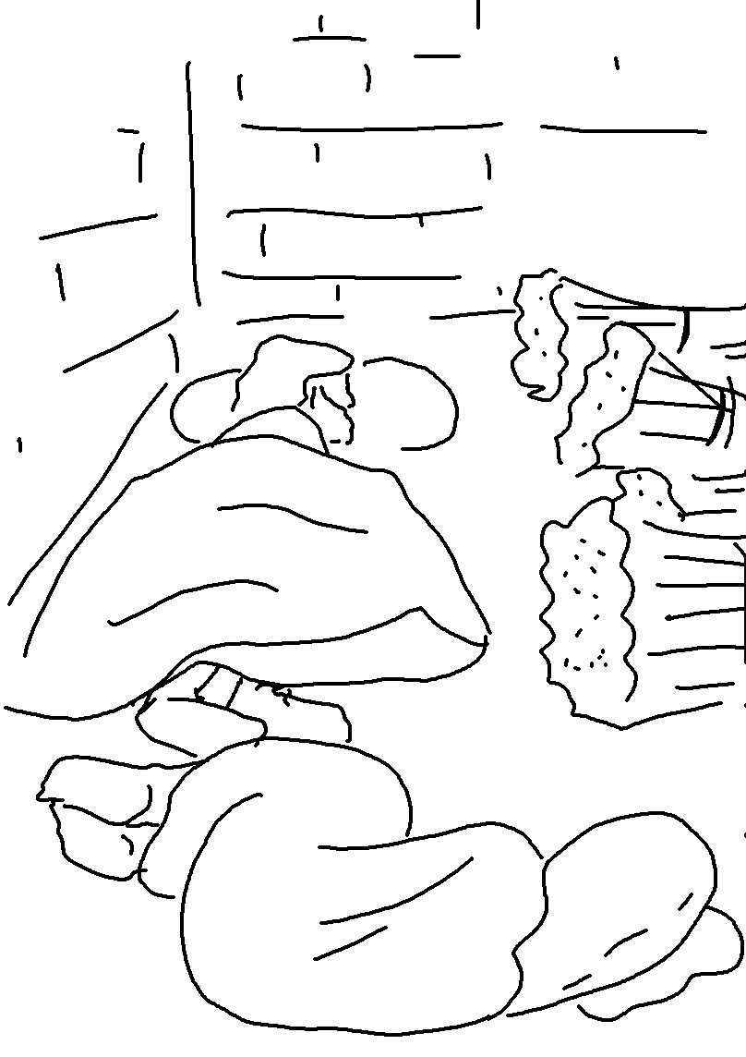
Your people will be my people, and your God will be my God.
Ruth 1:16_{NLT}

